2. Execute and display the results for the following commands in Kali Linux Operating Systems:
less command
more command
vi command
AIM:
To execute and demonstrate the less, more, and vi commands in the Kali Linux operating system and observe their outputs.
DESCRIPTION:
less Command — Description
The less command is used to view the contents of a text file one page at a time in the Linux operating system.
Example:
less test.txt
This command displays the contents of the test.txt file one page at a time.
Output:
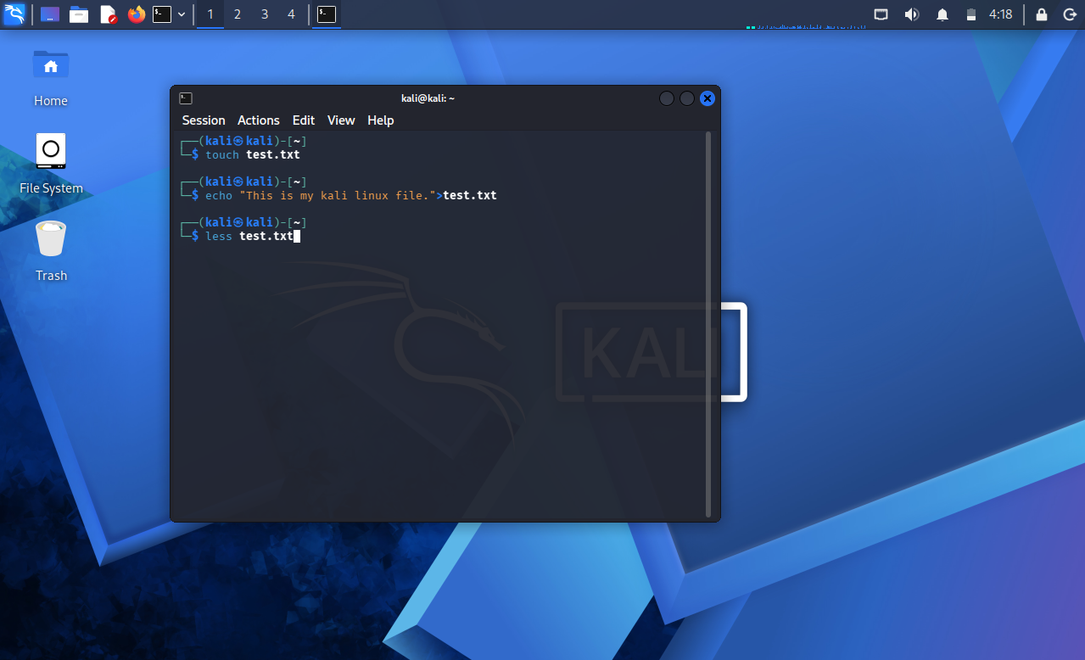
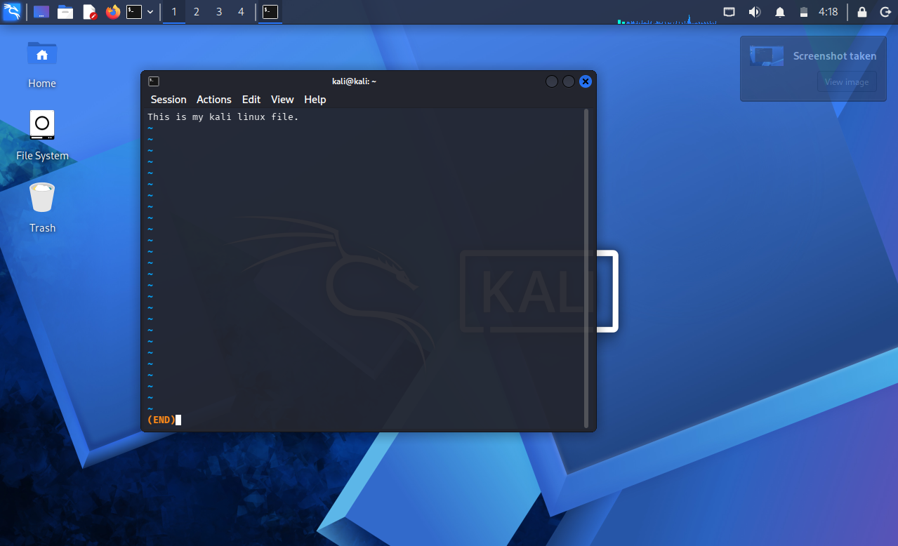
2. more Command — Description
The more command is used to view the contents of a text file one page at a time in the Linux operating system.
Example:
more test.txt
This command displays the contents of the test.txt file page by page.
Output:
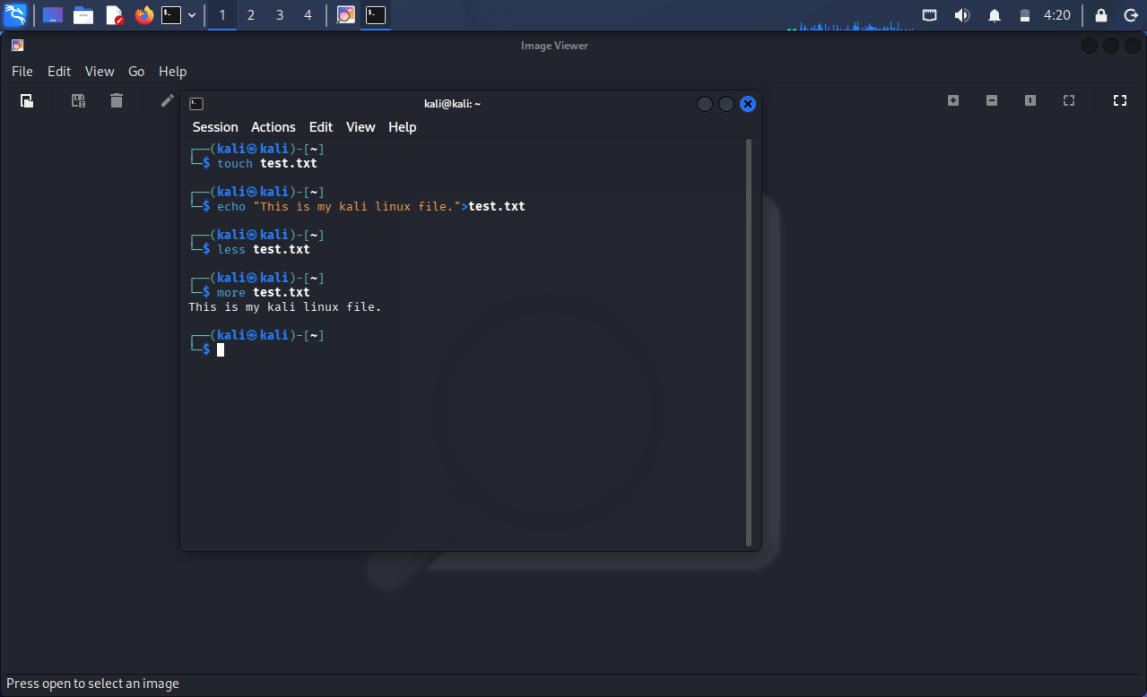
3. vi Command — Description
The vi command is used to create, edit, and save text files in the Linux operating system.
Example:
vi test.txt
This command opens the test.txt file in the vi text editor, where you can create or edit the file.
Output:
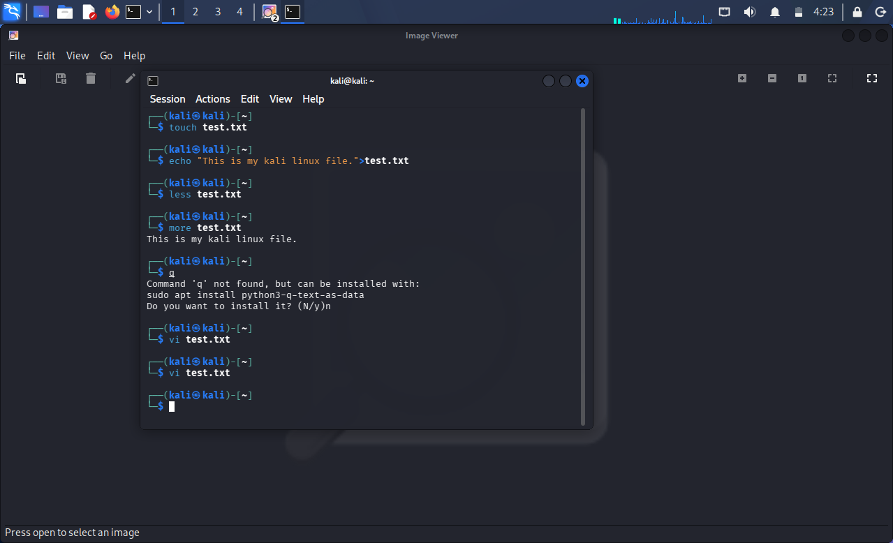
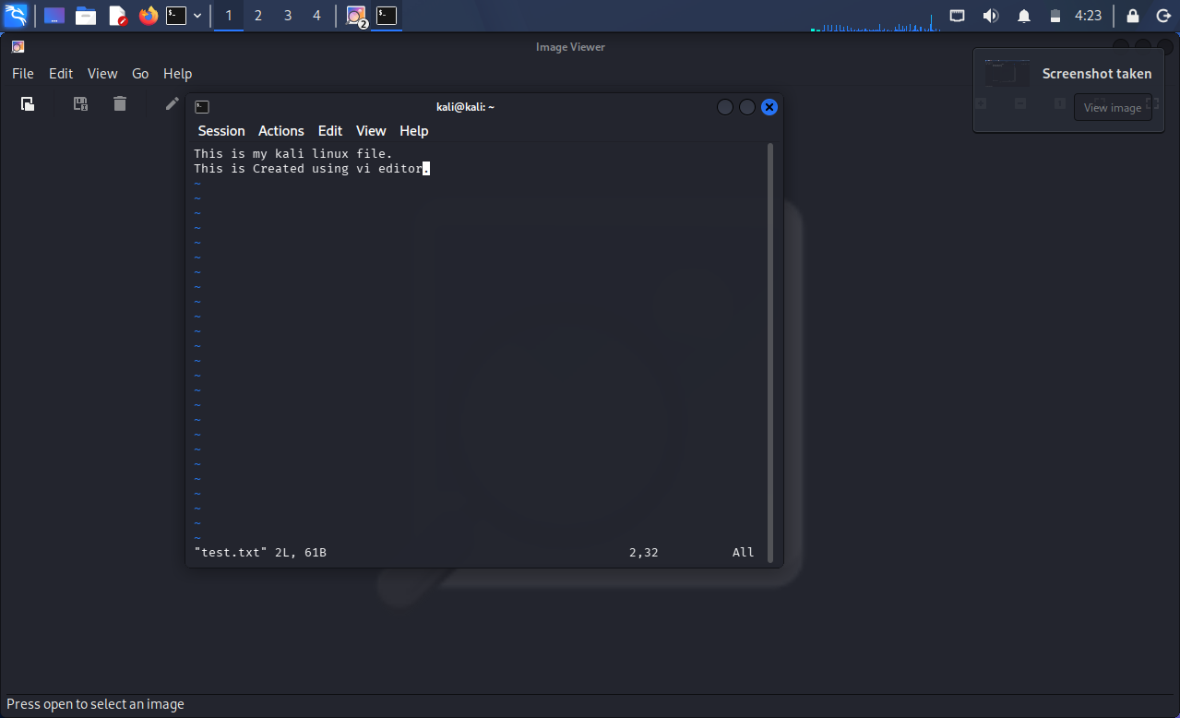

RESULTS:
The less, more, and vi commands were successfully executed in Kali Linux, and their respective outputs were displayed and observed.

